Hamilcar Knops & Anish Patil, Delft University of Technology

Converting excess wind power into valuable products: greening the Port of Rotterdam by “transhipment” of wind

H.P.A.Knops@tudelft.nl, anish.patil@protonventures.com

Hamilcar Knops is researcher at the Delft University of Technology.
With a background in physics and law, a PhD about the design of the rules for a liberalised electricity sector, and experience as a policy adviser, he focuses his research on how technological changes in the energy sector affect the sector’s legal and institutional organisation and vice versa.
Anish Patil is currently working on his doctoral thesis at the Delft University of Technology. His research focuses on the transition towards a sustainable energy system. Also, he is working part-time as a business development manager with Proton Ventures, Netherlands. Focus of his work is to develop Proton’s NFuel concept, which is based on decentralized production of Ammonia from surplus electricity from wind or solar, to be used as a fuel or a chemical feedstock.
Wind power is associated with fluctuations – that can be the difference between day and night, or seasonal, or in fact from minute to minute. These fluctuations are a big challenge for the electricity supply system. Technically they can lead to reliability and availability issues and economically they can cause volatile prices.
To elucidate the effect of the variable supply of wind energy, the demand and supply for West Denmark for the last week of March 2012 are given in Figure 1. As Denmark is a frontrunner in wind energy, these data can be regarded as a picture of the future of the Dutch state of affairs. The demand line shows a day/night rhythm, where the maximum demand doubles the minimum demand. On the supply side, the wind energy production fluctuates, randomly distributed in time, from zero to almost the maximum demand, which equals around 2000 MW for this West Denmark example. When wind power production exceeds power consumption, the price drops below zero.
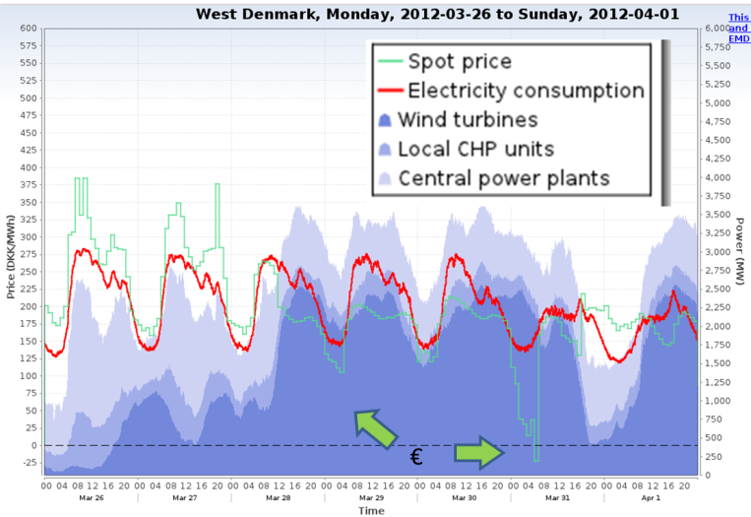The sustainability drivers at EU and Dutch level will result in an increased share of renewable energy sources. Wind energy is the most important renewable energy source in the Netherlands. To meet the long term targets, large investment in wind-energy will be inevitable in the near future. Operators of the grid and the system have to find ways to deal with the technical challenges posed by the fluctuations accompanying wind. At the same time, a sizeable production of wind power may offer economic opportunities since its marginal cost is almost zero and, hence, it could be a source of very cheap power. Could it be possible to use this opportunity in order to develop an efficient mechanism through which the peaks and troughs of wind power can be managed?
Figure 1 Electricity Demand and Supply in West Denmark⁴

A promising idea is to convert the temporary excess of wind-generated electricity into hydrogen gas and oxygen gas by electrolysis. The produced oxygen has (some) economic value in harbour industrial clusters, for instance in the Port of Rotterdam. The produced hydrogen can either be injected directly in the natural gas grid, mixed with evaporated LNG, or used as feedstock to produce ammonia or methanol
for industrial purposes. Another option is to apply the temporary excess of wind-generated electricity in batch processes that consume significant amounts of electricity, like the production of silicon carbide or for the production of steam.
The idea of combining wind power with other industrial sectors is not unique: German power provider Greenpeace Energy is constructing a unit that will convert excess wind power into hydrogen, which will then be sold to the German natural gas grid.. RWE, Bayer and Siemens join forces in the Co2rrect-project to produce chemicals based on wind-based hydrogen. Proton Ventures has developed a skid-based Wind2Ammonia unit, capable of storing fluctuating renewable energy in the form of Ammonia. Furthermore, in the Netherlands, stimulating results are being achieved on the island of Ameland.
In this project, a group of private parties and TU Delft want to investigate how options for dealing with the intermittency of wind energy can be implemented in the specific context of the Rotterdam Harbour, on Maasvlakte 2. The project partners are exploring a ‘greenfield situation’: there are no promising technical designs yet, insight in the options and requirements for the necessary institutional design is still lacking, the economic prospects are not yet clear, and prospective investors and owners have not been identified yet.
Therefore, the aim of this research project is to make an integrated technical and institutional design to outline how wind energy peaks can be ‘stored’ in the form of chemical feedstock while aiming at the greening of industrial processes in the Maasvlakte 2 region by making optimal use of the synergies that may exist in the Rotterdam Harbour area. Essentially, it means finding ways of converting excess wind energy into new products that can be used in or transported from the Port of Rotterdam, which we shortly refer to as the ‘transhipment of wind’.

http://www.emd.dk/el/
http://www.renewablesinternational.net/greenpeace-launches-power-to-gas/150/537/56730/
http://www.utilities.nl/opslag-van-windenergie-stapje-dichterbij.98819.lynkx
http://www.ameland.nl/index.php?simaction=content&mediumid=11&pagid=648
Parties that show interest in the development of the idea of using excess wind energy to produce hydrogen gas on Maasvlakte 2 are: The Road Project, E.On, Tennet, Port of Rotterdam, Proton Ventures and Stedin.

