**RSM Symposium on the economic value of**

**Corporate reputation**



October 19th, 2011

Rotterdam, the Netherlands

Erasmus University Rotterdam

[](http://www.rsm.nl/home/faculty/centres_of_expertise/rsm_centres/ccc) [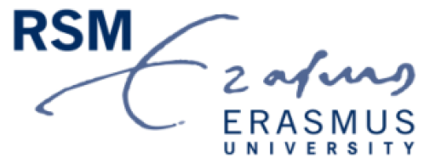](http://www.rsm.nl/) [](http://www.erim.eur.nl)

**Welcome**

The RSM Symposium on the Economic Value of Corporate Reputation is hosted by the Corporate Communication Centre at Rotterdam School of Management, Erasmus University Rotterdam. This symposium aims at uniting leading theorists and researchers focusing on ***the economic value of managing a good corporate reputation***. We believe that conferences gathering small groups of experts add most value in the creation and dissemination of academic knowledge. That is why we have invited a limited number of senior scholars to present at this symposium for this year.

We have put together an exciting two-day program at Erasmus University Rotterdam with the help of our sponsor, the Erasmus Research Institute of Management (ERIM). The symposium will take place on Wednesday, October 19th.

We are looking forward to welcoming you in Rotterdam!

** **

**Conference Chair: Conference Co-Chair:**

Prof. Dr. Cees B.M. van Riel Dr. Guido Berens

Office T11-56 Office T11-46

Rotterdam School of Management Rotterdam School of Management

Erasmus University Erasmus University

The Netherlands The Netherlands

Tel: +31 10 4082851 Tel: +31 10 4082260

Fax: +31 10 4089638 Fax: +31 10 4089638

Email: [CRiel@rsm.nl](mailto:CRiel@rsm.nl) Email: [GBerens@rsm.nl](mailto:GBerens@rsm.nl)

**Symposium Program Overview**

**Wednesday October 19th (Blijdorp Zaal, H17-01)**

8:30-9:00am Arrival and welcome

9:00-9:15 *Opening*

***Steef van de Velde,*** *Dean, Rotterdam School of Management, Erasmus University*

9:15-10:15 *Session 1: The economic cost of reputation loss*

***Pursey Heugens****, Erasmus University Rotterdam*

10:15-10:45 Break

10:45-11:45 *Session 2: The values of reputation: Institutional, strategic, and socioemotional*

***David Deephouse****, University of Alberta*

11:45-1:00pm Lunch

(Faculty Club)

1:00-2:00 *Session 3: Who gives a chit? Linking stakeholder perceptions to firm performance*

***Michael L. Barnett****, University of Oxford*

2:00-2:30 Break

2:30-3:30 *Session 4: Being known or being appreciated? The economic value of corporate reputation for investors*

***Yijing Wang****, Erasmus University Rotterdam*

3:30-4:30 *Discussion: research Agenda*

4:30-5:00 Wrap-up and Adjournment

**Distinguished Speakers**

The symposium is designed to provide a forum for pioneering research on corporate reputation management, where scholars share their best ideas and receive thoughtful, constructive feedback from other experts. Therefore, we highly appreciate the presence of our distinguished speakers.

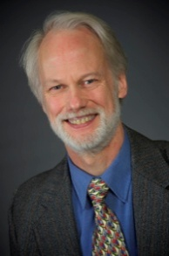 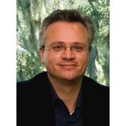

**Dr. David Deephouse Dr. Michael Barnett**

Professor of Strategic Management & Professor of Strategy,

Organization, Saïd Business School,

School of Business, University of Oxford, UK

University of Alberta, Canada

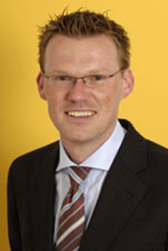

**Dr. Pursey Heugens**

Professor of Organization Theory,

Development, and Change

Rotterdam School of Management

Erasmus University